HW 10-1 Soln)

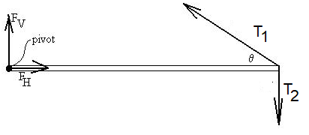To be in equilibrium, we require that the sums of the torques, x-component forces, and y-component forces be zero. Let x be horizontal and y be vertical.

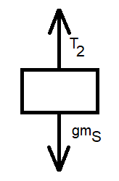  
The beam seems to be the central object on which most of the forces of interest act, so to keep track of the forces, draw a free-body diagram.

We’ll need to do an analysis for the forces acting on the sign as well:

$$+T_{2}-{gm}_{S}=0$$

$$T_{2}={gm}_{S}$$

The force from the hinge at the left is decomposed into its vertical and horizontal components.  Let L be the length of the beam.  Define the torques to be positive out of the page (CCW). Since the beam is in static equilibrium, we can *choose* our pivot about which to calculate the torques; we should get zero regardless of our choice.  I choose the hinge.   
So,

$$0\left(F_{V}\right)\sin\left(?\right)+ 0\left(F_{H}\right)\sin\left(?\right)+L\left(T_{1}\right)sinθ-L\left(T_{2}\right)\sin{90}=0$$

$$T_{1} sinθ=T_{2}$$

$$T_{1}=\frac{T_{2}}{sinθ}=\frac{{gm}_{S}}{sin30}=\frac{300}{0.5}=600 N .$$