HW 10-2 Soln)

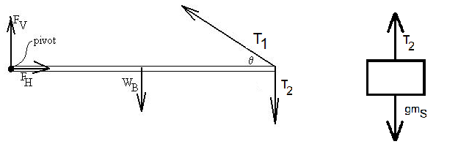To be in equilibrium, we require that the sums of the torques, x-component forces, and y-component forces be zero. Let x be horizontal and y be vertical.

The beam seems to be the central object on which most of the forces of interest act, so to keep track of the forces, draw a free-body diagram.

We’ll need to do an analysis for the forces acting on the sign as well:

$$+T_{2}-{gm}_{S}=0$$

$$T_{2}={gm}_{S}$$

The force from the hinge at the left is decomposed into its vertical and horizontal components.  Let L be the length of the beam. We can assume that the weight of the beam acts at the center of the beam. Define the torques to be positive out of the page (CCW). Since the beam is in static equilibrium, we can *choose* our pivot about which to calculate the torques; we should get zero regardless of our choice.  I choose the hinge.   
So,

$$0\left(F_{V}\right)\sin\left(?\right)+ 0\left(F_{H}\right)\sin\left(?\right)+L\left(T_{1}\right)sinθ-\frac{L}{2}W_{B}\sin{90}-L\left(T_{2}\right)\sin{90}=0$$

$$T_{1} sinθ=T_{2}+\frac{W_{B}}{2}={gm}_{S}+\frac{W_{B}}{2}$$

$$T_{1}=\frac{T_{2}+\frac{W_{B}}{2}}{sinθ}=\frac{{gm}_{S}+\frac{W_{B}}{2}}{sin25}=\frac{500+\frac{300}{2}}{0.423}=1538 N .$$