Section 5 Master Question.

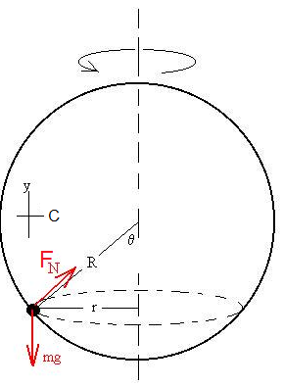The bead moves in a circle of radius r = R sin θ. Make one axis toward the center of the circle and the other vertical.

The forces acting on the bead are the weight and the normal force. The normal force acts perpendicularly to the surfaces of the wire and the bead, *i.e*., towards the center of the hoop.

Write NII:

C: FN sinθ = m aC = mrω2. = m R sinθ ω2.

Y: FN cos θ – gm = m ay = 0.

Re-arrange and divide:

$$\frac{F_{N} \sin{θ}}{F_{N} \cos{θ}}= \frac{mR \sin{θ}ω^{2}}{gm}$$

$$\frac{\sin{θ}}{ \cos{θ}}= \frac{R \sin{θ}ω^{2}}{g}$$

We want to solve for the angle as a function of omega. There are two solutions that are actually independent of omega, namely when theta equals either 0o or 180o. That is, the bead can sit at the bottom or balance precariously at the top regardless of the value of omega.

Now, cancel the sines to find another solution:

$$\cos{θ}= \frac{g}{Rω^{2}} .$$

Here we see that when omega is high, the angle approached 90o, as might be expected. As the rotation rate decreases, the angle also decreases, but NOT to zero as omega goes to zero. Instead, the angle goes to zero when ω→ (g/R)1/2.

So, when ω > (g/R)1/2, there are three possible stable angles, but when ω < (g/R)1/2, there are only the two extreme positions.